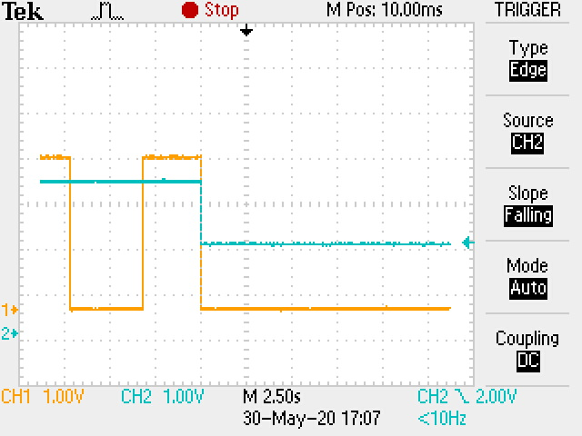  Tx Raspi  Tx UPS | Shutdown to standby  Slow scan of DC level on the lines.  Tx UPS uses pull ups Raspi  Tx Raspi
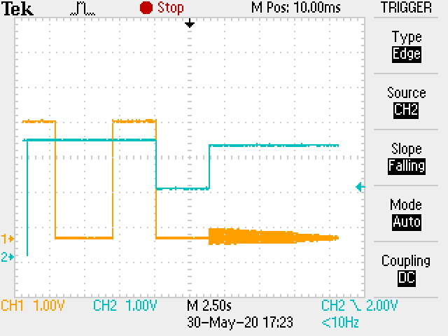 | Shutdown - power off
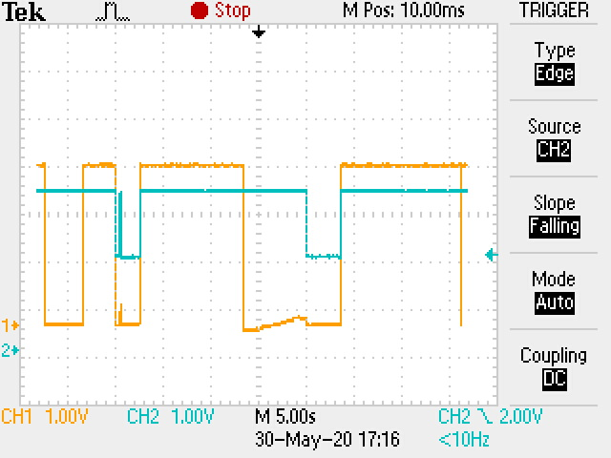 | Shutdown restart
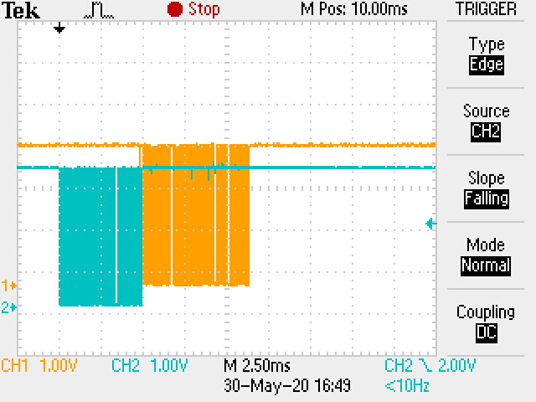 | Command - Acknowledge

